Lane Merger Functional Design Specifications
  - Project NameMIPI CSI Controller IP
  - Version 1.0

  - Block Owner
Abdelrahman Elsayed
  - Authors
Abdelrahman Elsayed

This Page is left Blank Intentionally

Table of Contents
1 Table of Contents 1
2 Revision History 2
3 Overview 3
4 Operation and Description 3
4.1 Digital Interface 3
4.1.1 Parameters Names 3
4.1.2 Ports Names 3
4.2 Functional Description 3
4.3 Block Diagram 3
4.4 Timing Diagram 3
4.5 Verification Requirements 3

Revision History
Version | Date | Author(s) | Revision Notes | Owner Approval

Overview
The Lane Merger (Serializer) is a fundamental receive-side module within the MIPI CSI Controller IP. It is responsible for aggregating concurrent byte streams arriving from 1, 2, or 4 parallel MIPI lanes back into a single sequential byte stream. Implementing a strict pull-based architecture with pipelined internal buffering, the module ensures continuous, stall-free, and zero dead-cycle data delivery to the downstream MAC layer.

Operation and Description

Digital Interface

Parameters Names
Parameter Name | Default | Description
N/A | N/A | This module does not utilize top-level instantiation parameters. Configuration is handled dynamically via the i_active_lanes input port.

Ports Names
Port Name | Port Width | Port Type | Description
i_clk | 1 | Input | System core clock.
i_rst_n | 1 | Input | Active-low asynchronous system reset.
i_active_lanes | 3 | Input | Configuration input defining the number of active lanes (e.g., 1, 2, or 4).
i_packet_active | 1 | Input | Packet status flag indicating an active reception sequence.
i_rx_ready | 1 | Input | Flag indicating the upstream PPI RX FIFOs have valid data ready.
i_lane[0:3]_data | 8 | Input | Parallel data inputs from the four PPI RX FIFOs.
i_lane[0:3]_vld | 1 | Input | Parallel valid signals corresponding to the parallel data inputs.
o_pull_data | 1 | Output | Read enable (pull) control signal driving the upstream PPI RX FIFOs.
o_merged_data | 8 | Output | The aggregated sequential (serialized) byte stream to the MAC.
o_merged_valid | 1 | Output | Valid signal accompanying the serialized output data.

Functional Description
The Lane Merger module dynamically adapts to the physical lane configuration and operates through three integrated sub-mechanisms:
- Startup Delay & Active State Controller: To ensure proper data alignment and prevent premature FIFO reads, the module implements a brief initialization delay. Upon receiving i_rx_ready, a 3-cycle startup_delay countdown initiates. Once the delay expires, the r_is_active flag asserts, allowing the generation of the o_pull_data signal to fetch data from the upstream FIFOs safely.
- Output Multiplexer FSM (Next State Logic): A highly optimized state machine tracks the serialization process based on the i_active_lanes setting. Starting at state 0, it calculates the next state (1, 2, or 3) depending on how many lanes are active. After iterating through the active lanes, it seamlessly loops back to state 0 to trigger the next parallel pull.
- Datapath & Pipelined Buffering (Zero Dead-Cycles): The datapath is designed to maintain 100% bus utilization.
  - State 0: Asserts o_pull_data, directly routes Lane 0 to the output (o_merged_data), and concurrently latches Lanes 1, 2, and 3 (along with their valid flags) into internal pipelined buffers (r_buf1, r_buf2, r_buf3).
  - States 1/2/3: Sequentially streams the buffered data to the output in the subsequent clock cycles. This architecture guarantees that parallel-to-serial conversion occurs without introducing any empty (dead) clock cycles.

Block Diagram

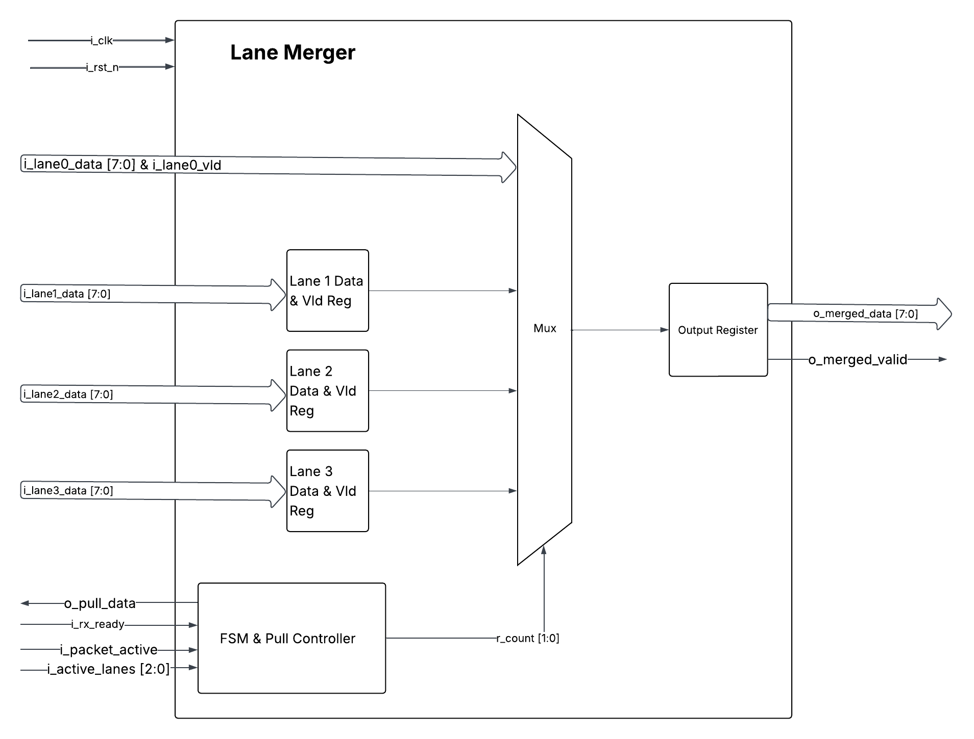

Timing Diagram

.
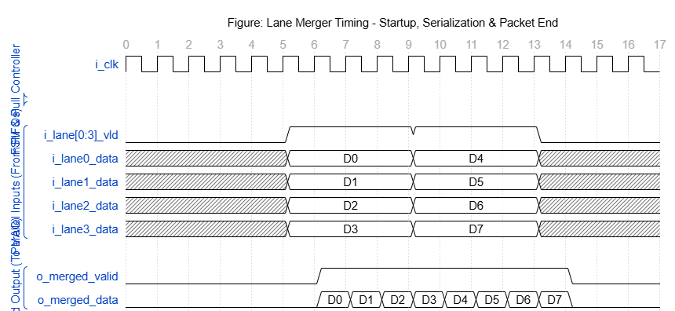

Verification Requirements

